**Local Traffic Committee**

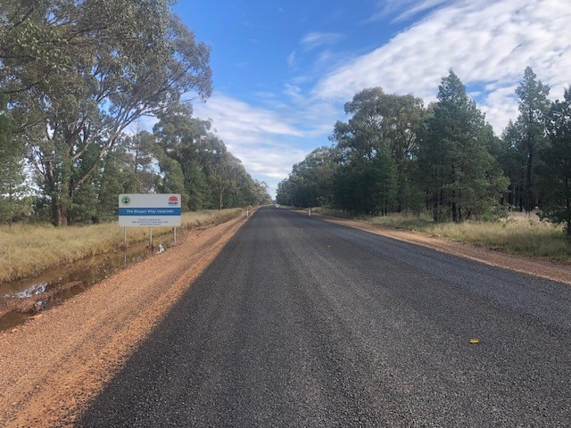

**About the Local Traffic Committee**

Transport for NSW, formerly Roads and Maritime Services (RMS), is the legislative body responsible for the control of traffic on all roads in NSW. Transport for NSW has delegated aspects of traffic control on local roads to Councils; deeming it the most effective way to deal with traffic related matters on local roads.

The Local Traffic Committee (LTC) is primarily a technical review committee. It advises Council on traffic control matters that have been referred to Council. This includes events that will impact local roads or a sporting event using the road. These matters must be related to prescribed traffic control devices or traffic control facilities for which Council has delegated authority.

The Committee has 4 formal (voting) members:

* Local Council representative
* NSW Police Force representative
* Transport for NSW representative
* Local State Member of Parliament (MP) or their nominee

**How Does it Operate?**

Local Councils must refer all traffic related matters to the LTC prior to exercising its delegated powers.  Matters related to classified roads or functions that have not been delegated to Council must be referred directly to Transport for NSW or relevant organisation, not the LTC. However, the Transport for NSW will generally seek the views of Council on classified road traffic issues, via the general traffic advice process.

The LTC considers the technical merits of each proposal it receives and ensures that the proposal meets current technical guidelines.  The LTC has no decision-making powers, and local Councils are not bound by the advice of LTCs.

**Meetings**

The LTC is not a committee under the Local Government Act 1993. The operating arrangements for the LTC are contained within the [RTA Guidelines](http://www.rms.nsw.gov.au/business-industry/partners-suppliers/documents/technical-manuals/ltcguidev13_i.pdf) - *A guide to the delegation* *to councils for the regulation of traffic, including the operation of* *Traffic Committees*; and the LTC for Lachlan Shire Council is held quarterly. All proposals recommended by the LTC must be formally approved by the elected local Council, subject to certain limitations.

**Can a Member of the Public attend a Local Traffic Committee Meeting?**

LTC meetings do not have public galleries.